Mockito Exercises

Name: Shubham Sangram Bej

Aim
To understand and implement unit testing using Mockito with JUnit 5 by creating mock objects, stubbing methods, verifying interactions, handling void methods, testing multiple return values, verifying interaction order, and testing exceptions.

Objectives
- To learn the basics of mocking using Mockito.
- To understand method stubbing and interaction verification.
- To use argument matchers for flexible verification.
- To test void methods using Mockito.
- To simulate multiple return values from mocked methods.
- To verify the order of method invocations.
- To test exception handling in mocked methods.

Software Requirements
- IntelliJ IDEA Community Edition
- Java JDK 21
- Apache Maven
- JUnit 5 (JUnit Jupiter)
- Mockito
- Git
- GitHub

Theory
Mockito is a popular Java framework used for creating mock objects during unit testing. It allows developers to isolate the class under test by replacing external dependencies with mock implementations. Mockito integrates seamlessly with JUnit and helps verify method calls, simulate different behaviours, and improve the reliability of unit tests.

Key Features of Mockito
- Mocking external dependencies
- Stubbing method responses
- Verifying method invocations
- Argument matching
- Handling void methods
- Simulating exceptions
- Verifying interaction order
- Easy integration with JUnit 5

Exercises Performed

Exercise 1 – Mocking and Stubbing

Description
A mock implementation of the ExternalApi interface was created using Mockito. The getData() method was stubbed to return a predefined value. The MyService class was tested using the mocked dependency.

Concepts Used
- mock()
- when()
- thenReturn()
- assertEquals()

Outcome
The mocked API returned the predefined value successfully, and the service method produced the expected output.
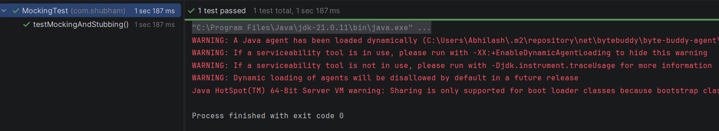

Exercise 2 – Verifying Interactions

Description
A mock object was created, and the service method was executed. Mockito's verify() method was used to confirm that the expected API method was invoked.

Concepts Used
- verify()

Outcome
The interaction between the service and the mocked API was successfully verified.
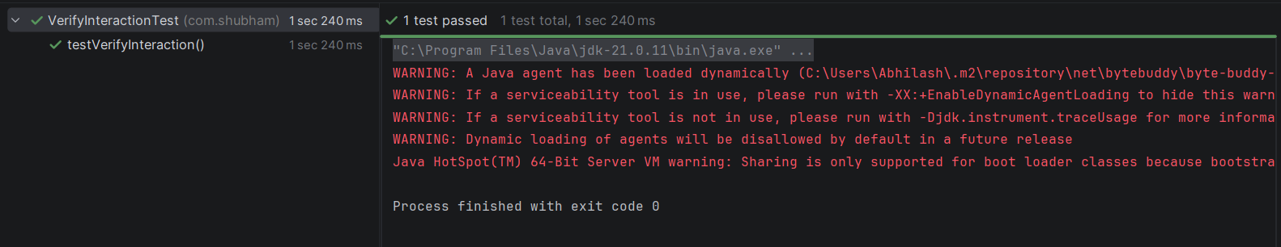

Exercise 3 – Argument Matching

Description
Mockito argument matchers were used to verify that a method was called regardless of the exact string value passed.

Concepts Used
- anyString()
- verify()

Outcome
The interaction was verified successfully using argument matching.
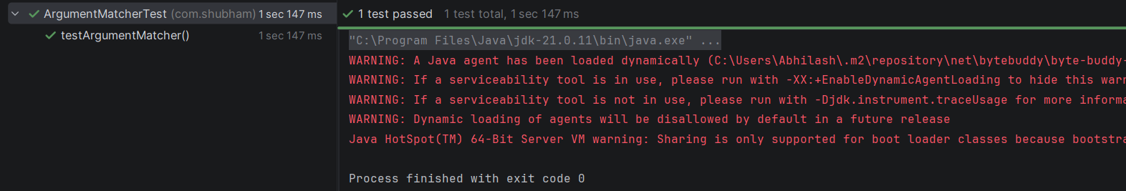

Exercise 4 – Handling Void Methods

Description
A void method was stubbed using doNothing(). The service invoked the method, and Mockito verified that the method call occurred successfully.

Concepts Used
- doNothing()
- verify()

Outcome
The void method executed successfully and the interaction was verified.
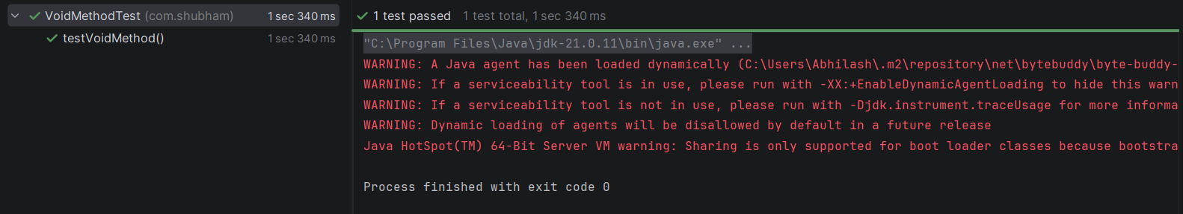

Exercise 5 – Mocking with Multiple Return Values

Description
A mocked method was configured to return different values on consecutive calls using chained thenReturn() statements.

Concepts Used
- thenReturn()

Outcome
Each consecutive invocation returned the expected value, demonstrating sequential stubbing.
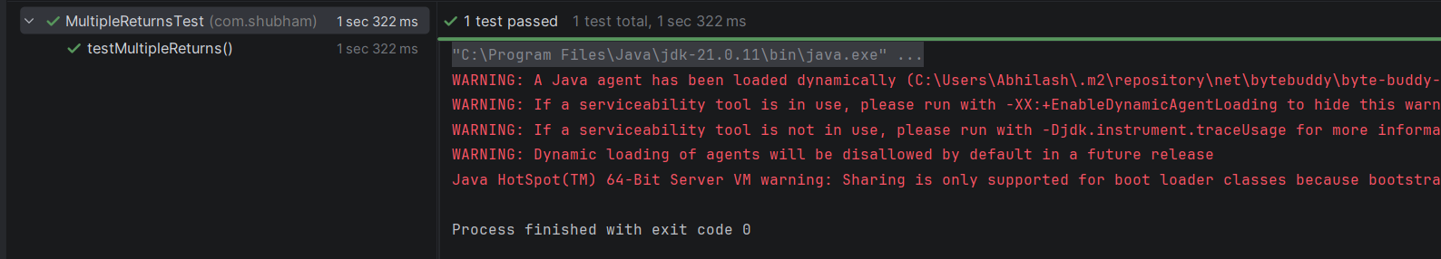

Exercise 6 – Verifying Interaction Order

Description
Mockito's InOrder verification was used to ensure that multiple method calls occurred in the correct sequence.

Concepts Used
- InOrder
- verify()

Outcome
The order of interactions was verified successfully.
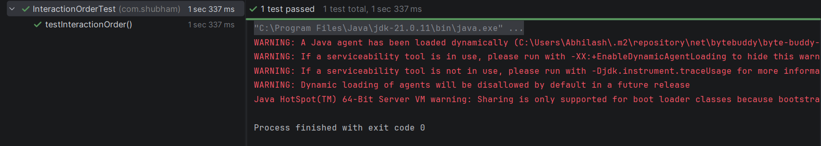

Exercise 7 – Handling Void Methods with Exceptions

Description
A void method was configured to throw an exception using doThrow(). JUnit's assertThrows() verified that the expected exception was generated.

Concepts Used
- doThrow()
- assertThrows()

Outcome
The expected exception was successfully thrown and validated.
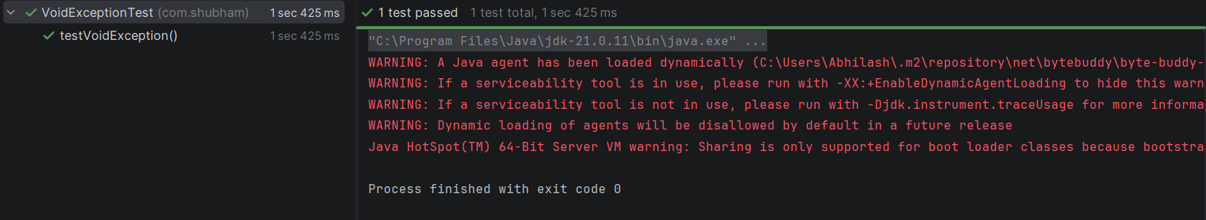

Project Structure
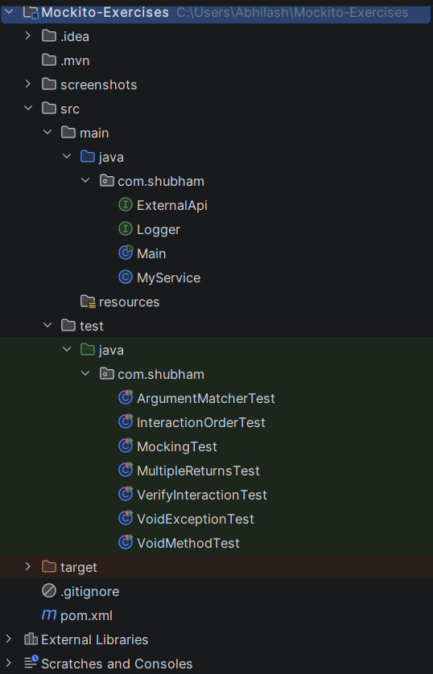

Results
The Mockito exercises were successfully implemented and executed. The following concepts were demonstrated:
- Mock object creation
- Method stubbing
- Interaction verification
- Argument matching
- Handling void methods
- Multiple return values
- Interaction order verification
- Exception handling in mocked methods
All test cases executed successfully using JUnit 5 and Mockito.

Advantages of Mockito
- Simplifies unit testing by isolating dependencies.
- Eliminates the need for actual external services.
- Makes tests faster and more reliable.
- Supports flexible argument matching.
- Enables verification of method calls and execution order.
- Allows simulation of exceptional scenarios.
- Integrates easily with Maven and JUnit 5.

Conclusion
The Mockito Hands-On Exercises successfully demonstrated the practical use of Mockito for unit testing in Java applications. By creating mock objects and simulating external dependencies, it was possible to test application logic independently of real implementations. Features such as stubbing, interaction verification, argument matching, exception testing, and execution order verification significantly improve the quality, maintainability, and reliability of software. Mockito, combined with JUnit 5, provides a powerful framework for developing comprehensive and efficient unit tests.

References
- Mockito Documentation – https://site.mockito.org/
- JUnit 5 User Guide – https://junit.org/junit5/docs/current/user-guide/
- Apache Maven Documentation – https://maven.apache.org/
- Oracle Java Documentation – https://docs.oracle.com/en/java/

Codes Used

pom.xml:
<?xml version="1.0" encoding="UTF-8"?>
<project xmlns="http://maven.apache.org/POM/4.0.0"
xmlns:xsi="http://www.w3.org/2001/XMLSchema-instance"
xsi:schemaLocation="https://maven.apache.org/POM/4.0.0
https://maven.apache.org/xsd/maven-4.0.0.xsd">
<modelVersion>4.0.0</modelVersion>
<groupId>com.shubham</groupId>
<artifactId>Mockito-Exercises</artifactId>
<version>1.0-SNAPSHOT</version>
<properties>
<maven.compiler.source>21</maven.compiler.source>
<maven.compiler.target>21</maven.compiler.target>
<project.build.sourceEncoding>UTF-8</project.build.sourceEncoding>
<junit.version>5.10.2</junit.version>
<mockito.version>5.12.0</mockito.version>
</properties>
<dependencies>
<!-- JUnit -->
<dependency>
<groupId>org.junit.jupiter</groupId>
<artifactId>junit-jupiter</artifactId>
<version>${junit.version}</version>
<scope>test</scope>
</dependency>
<!-- Mockito -->
<dependency>
<groupId>org.mockito</groupId>
<artifactId>mockito-core</artifactId>
<version>${mockito.version}</version>
<scope>test</scope>
</dependency>
</dependencies>
<build>
<plugins>
<plugin>
<groupId>org.apache.maven.plugins</groupId>
<artifactId>maven-surefire-plugin</artifactId>
<version>3.2.5</version>
</plugin>
</plugins>
</build>
</project>

ExternalApi.java:
package com.shubham;
public interface ExternalApi {
String getData();
void log(String message);
}

Logger.java:
package com.shubham;
public interface Logger {
void log(String message);
}

MyService.java:
package com.shubham;
public class MyService {
private ExternalApi api;
public MyService(ExternalApi api) {
this.api = api;
}
public String fetchData() {
return api.getData();
}
public void sendMessage(String message) {
api.log(message);
}
}

ArgumentMatcherTest.java:
package com.shubham;
import org.junit.jupiter.api.Test;
import static org.mockito.ArgumentMatchers.anyString;
import static org.mockito.Mockito.*;
public class ArgumentMatcherTest {
@Test
void testArgumentMatcher(){
ExternalApi api = mock(ExternalApi.class);
MyService service = new MyService(api);
service.sendMessage("Hello Mockito");
verify(api).log(anyString());
}
}

InteractionOrderTest.java:
package com.shubham;
import org.junit.jupiter.api.Test;
import org.mockito.InOrder;
import static org.mockito.Mockito.*;
public class InteractionOrderTest {
@Test
void testInteractionOrder(){
ExternalApi api = mock(ExternalApi.class);
api.log("First");
api.log("Second");
InOrder order = inOrder(api);
order.verify(api).log("First");
order.verify(api).log("Second");
}
}

MockingTest.java:
package com.shubham;
import org.junit.jupiter.api.Test;
import static org.junit.jupiter.api.Assertions.*;
import static org.mockito.Mockito.*;
public class MockingTest {
@Test
void testMockingAndStubbing(){
ExternalApi api = mock(ExternalApi.class);
when(api.getData()).thenReturn("Mock Data");
MyService service = new MyService(api);
assertEquals("Mock Data", service.fetchData());
}
}

MultipleReturnsTest.java:
package com.shubham;
import org.junit.jupiter.api.Test;
import static org.junit.jupiter.api.Assertions.*;
import static org.mockito.Mockito.*;
public class MultipleReturnsTest {
@Test
void testMultipleReturns(){
ExternalApi api = mock(ExternalApi.class);
when(api.getData())
.thenReturn("First")
.thenReturn("Second")
.thenReturn("Third");
assertEquals("First", api.getData());
assertEquals("Second", api.getData());
assertEquals("Third", api.getData());
}
}

VerifyInteractionTest.java:
package com.shubham;
import org.junit.jupiter.api.Test;
import static org.mockito.Mockito.*;
public class VerifyInteractionTest {
@Test
void testVerifyInteraction(){
ExternalApi api = mock(ExternalApi.class);
when(api.getData()).thenReturn("Mockito");
MyService service = new MyService(api);
service.fetchData();
verify(api).getData();
}
}

VoidExceptionTest.java:
package com.shubham;
import org.junit.jupiter.api.Test;
import static org.junit.jupiter.api.Assertions.assertThrows;
import static org.mockito.ArgumentMatchers.anyString;
import static org.mockito.Mockito.*;
public class VoidExceptionTest {
@Test
void testVoidException(){
ExternalApi api = mock(ExternalApi.class);
doThrow(new RuntimeException("Error"))
.when(api)
.log(anyString());
assertThrows(RuntimeException.class,
() -> api.log("Mockito"));
}
}

VoidMethodTest.java:
package com.shubham;
import org.junit.jupiter.api.Test;
import static org.mockito.Mockito.*;
public class VoidMethodTest {
@Test
void testVoidMethod(){
ExternalApi api = mock(ExternalApi.class);
doNothing().when(api).log(anyString());
MyService service = new MyService(api);
service.sendMessage("Testing");
verify(api).log("Testing");
}
}

